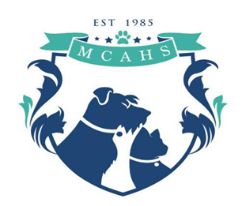
__________________________________________________________________
2020 Membership
We don’t receive any state or federal money to operate. We are not affiliated with nor do we receive funding from national organizations such as The Humane Society of the United States. Donations, grants, membership and adoption fees, and fundraising efforts are our sole sources of income.
If the animals could speak, they would say “Thank you.”

______ Single Membership $25 ______ Family Membership $40

______ Business Sponsorship $100 (please include a business card)
Business sponsorships include a link on our website, newsletter sponsorship.

May we display flyers promoting our fundraising events or adoptable pets in your place of business?(Please Circle) Yes Sorry, but NO
I am interested in: (circle all that apply)
Name:___________________________________ Fostering,Volunteering at the shelter,
Address: _________________________________ Volunteering at fundraisers/ events,
Phone: _______________________________________ Becoming a board member

May we publish your name in our newsletter? YES NO
____ I DO NOT wish to receive the newsletter to save the shelter money on postage, etc.
____ Please add me to your E-mail list for the electronic version of the newsletter and special announcements. E-mail address:_______________________________

May we give out your name as being a MCAHS member? YES/NO

Additional Donation(s)
$_______ Please use towards__________________________
$_______ In honor of ____________________________
$_______ In memory of__________________________

